-- Data Cleaning

CREATE DATABASE layoff_db;

USE layoff_db;

-- 0. Load initial data

SELECT * FROM layoffs;

-- 1. Remove Duplicates

-- Create staging table

CREATE TABLE layoff_staging AS

SELECT * FROM layoffs;

SELECT * FROM layoff_staging;

-- Identify duplicates using ROW_NUMBER

WITH cte_layoff AS (

SELECT *,

ROW_NUMBER() OVER (PARTITION BY company, location, industry, total_laid_off, percentage_laid_off,

`date`, stage, country, funds_raised_millions) AS row_num

FROM layoff_staging

)

SELECT * FROM cte_layoff WHERE row_num > 1;

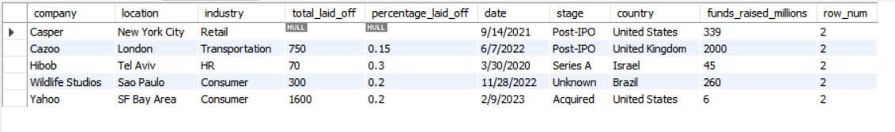

-- Delete duplicates

WITH cte_layoff AS (

SELECT *,

ROW_NUMBER() OVER (PARTITION BY company, location, industry, total_laid_off, percentage_laid_off,

`date`, stage, country, funds_raised_millions) AS row_num

FROM layoff_staging

)

DELETE FROM cte_layoff WHERE row_num > 1;

-- Create layoff_staging2 table with row_num

CREATE TABLE layoff_staging2 (

company TEXT,

location TEXT,

industry TEXT,

total_laid_off INT DEFAULT NULL,

percentage_laid_off TEXT,

`date` TEXT,

stage TEXT,

country TEXT,

funds_raised_millions INT DEFAULT NULL,

row_num INT

);

-- Insert cleaned data into layoff_staging2

INSERT INTO layoff_staging2

SELECT *, ROW_NUMBER() OVER (PARTITION BY company, location, industry, total_laid_off, percentage_laid_off,

`date`, stage, country, funds_raised_millions) AS row_num

FROM layoff_staging;

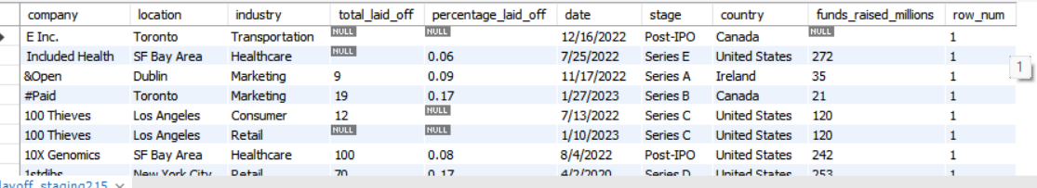

-- Disable safe updates

SET SQL_SAFE_UPDATES = 0;

-- Remove duplicates from layoff_staging2

DELETE FROM layoff_staging2 WHERE row_num > 1;

-- 2. Standardize Data

-- Trim company name whitespace

UPDATE layoff_staging2 SET company = TRIM(company);

-- Standardize 'Crypto' industry name

SELECT industry FROM layoff_staging2 WHERE industry LIKE 'Crypto%';

UPDATE layoff_staging2 SET industry = 'Crypto' WHERE industry LIKE 'Crypto%';

-- Standardize country names by removing trailing '.'

SELECT DISTINCT country, TRIM(TRAILING '.' FROM country) FROM layoff_staging2 ORDER BY 1;

UPDATE layoff_staging2 SET country = TRIM(TRAILING '.' FROM country) WHERE country LIKE '%.';

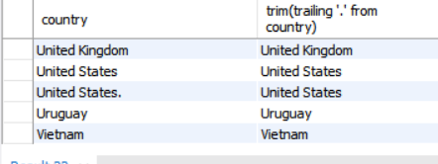

-- Convert date from text to proper DATE format

SELECT `date`, STR_TO_DATE(`date`, '%m/%d/%Y') FROM layoff_staging2;

UPDATE layoff_staging2 SET `date` = STR_TO_DATE(`date`, '%m/%d/%Y');

ALTER TABLE layoff_staging2 MODIFY `date` DATE;

-- 3. Handle Null or Blank Values

-- Find rows with both total_laid_off and percentage_laid_off NULL

SELECT COUNT(*) FROM layoff_staging2 WHERE total_laid_off IS NULL AND percentage_laid_off IS NULL;

-- Find and replace blank industry with NULL

SELECT * FROM layoff_staging2 WHERE industry IS NULL OR industry = '';

UPDATE layoff_staging2 SET industry = NULL WHERE industry = '';

-- Use self join to impute missing industry

SELECT * FROM layoff_staging2 t1

JOIN layoff_staging2 t2 ON t1.company = t2.company

WHERE (t1.industry IS NULL OR t1.industry = '') AND t2.industry IS NOT NULL;

UPDATE layoff_staging2 t1

JOIN layoff_staging2 t2 ON t1.company = t2.company

SET t1.industry = t2.industry

WHERE (t1.industry IS NULL OR t1.industry = '') AND t2.industry IS NOT NULL;

-- Delete fully NULL layoff rows

DELETE FROM layoff_staging2 WHERE total_laid_off IS NULL AND percentage_laid_off IS NULL;

-- 4. Remove row_num column after cleaning

ALTER TABLE layoff_staging2 DROP COLUMN row_num;